Spring
# Source: AI Source: Provided by: [Data Path: Persons Table -> ID Column: 1, Name_En Column: Motasem Essam] -> From: [ChatGPT] on [7/17/2026]
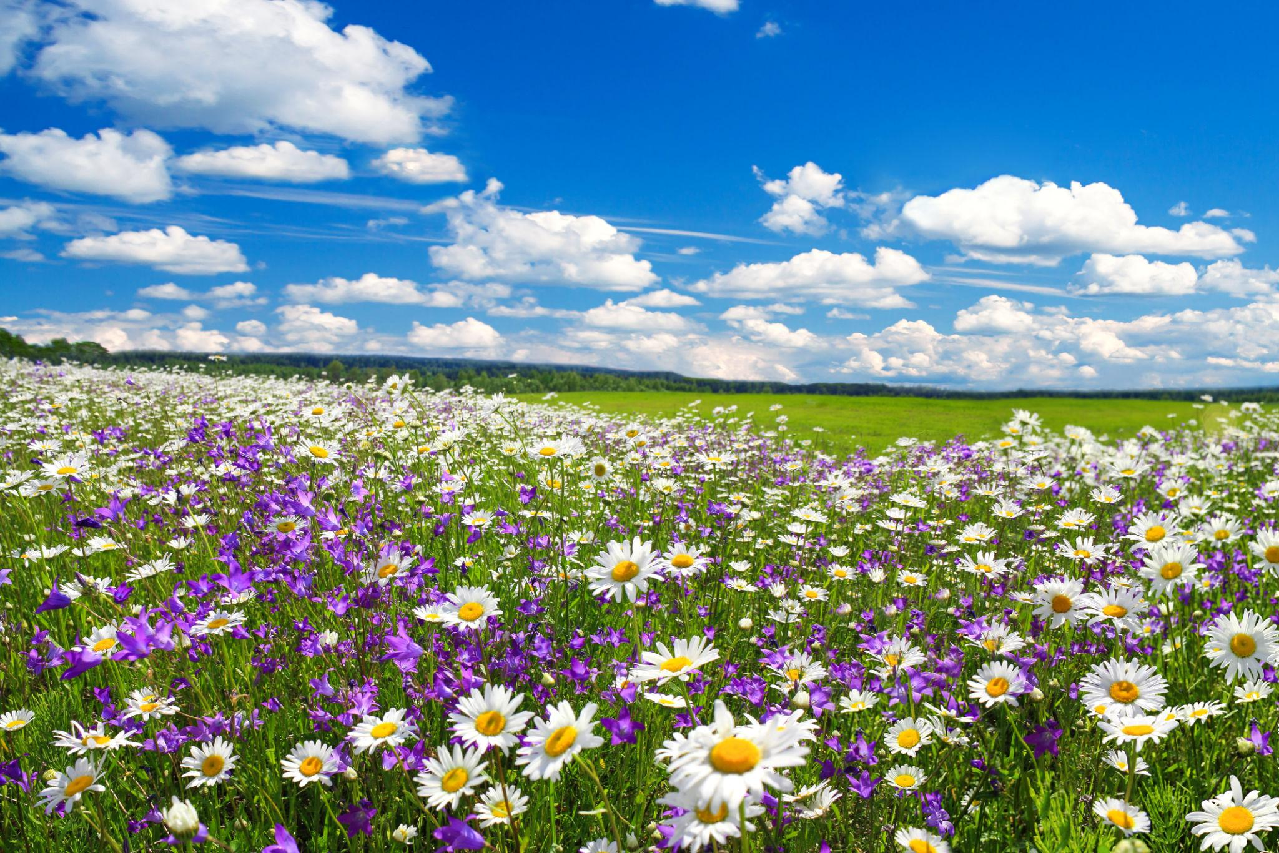
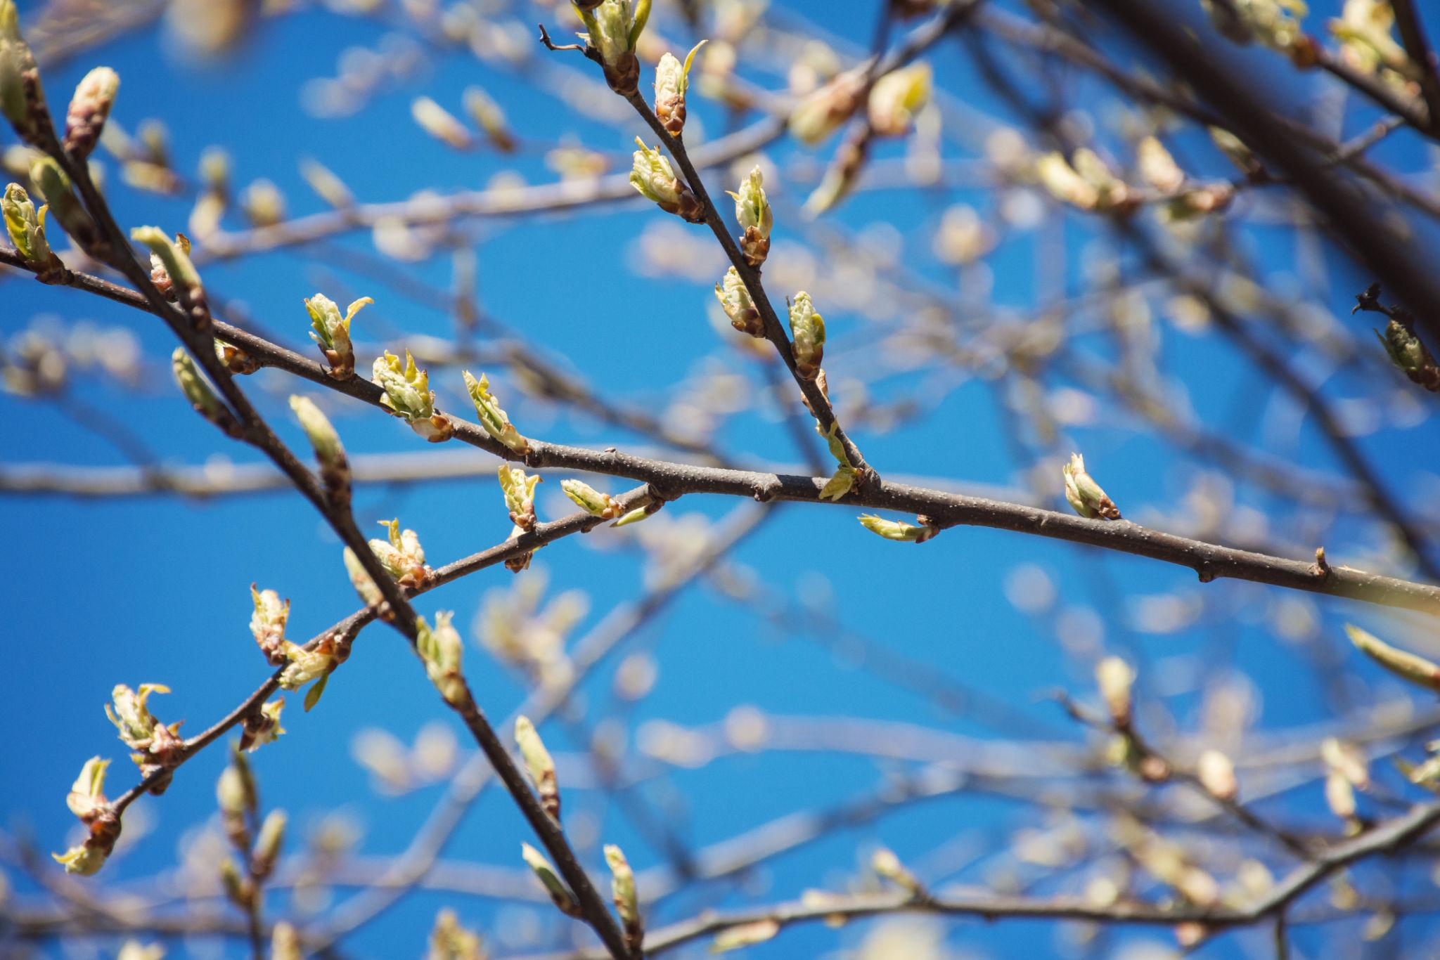
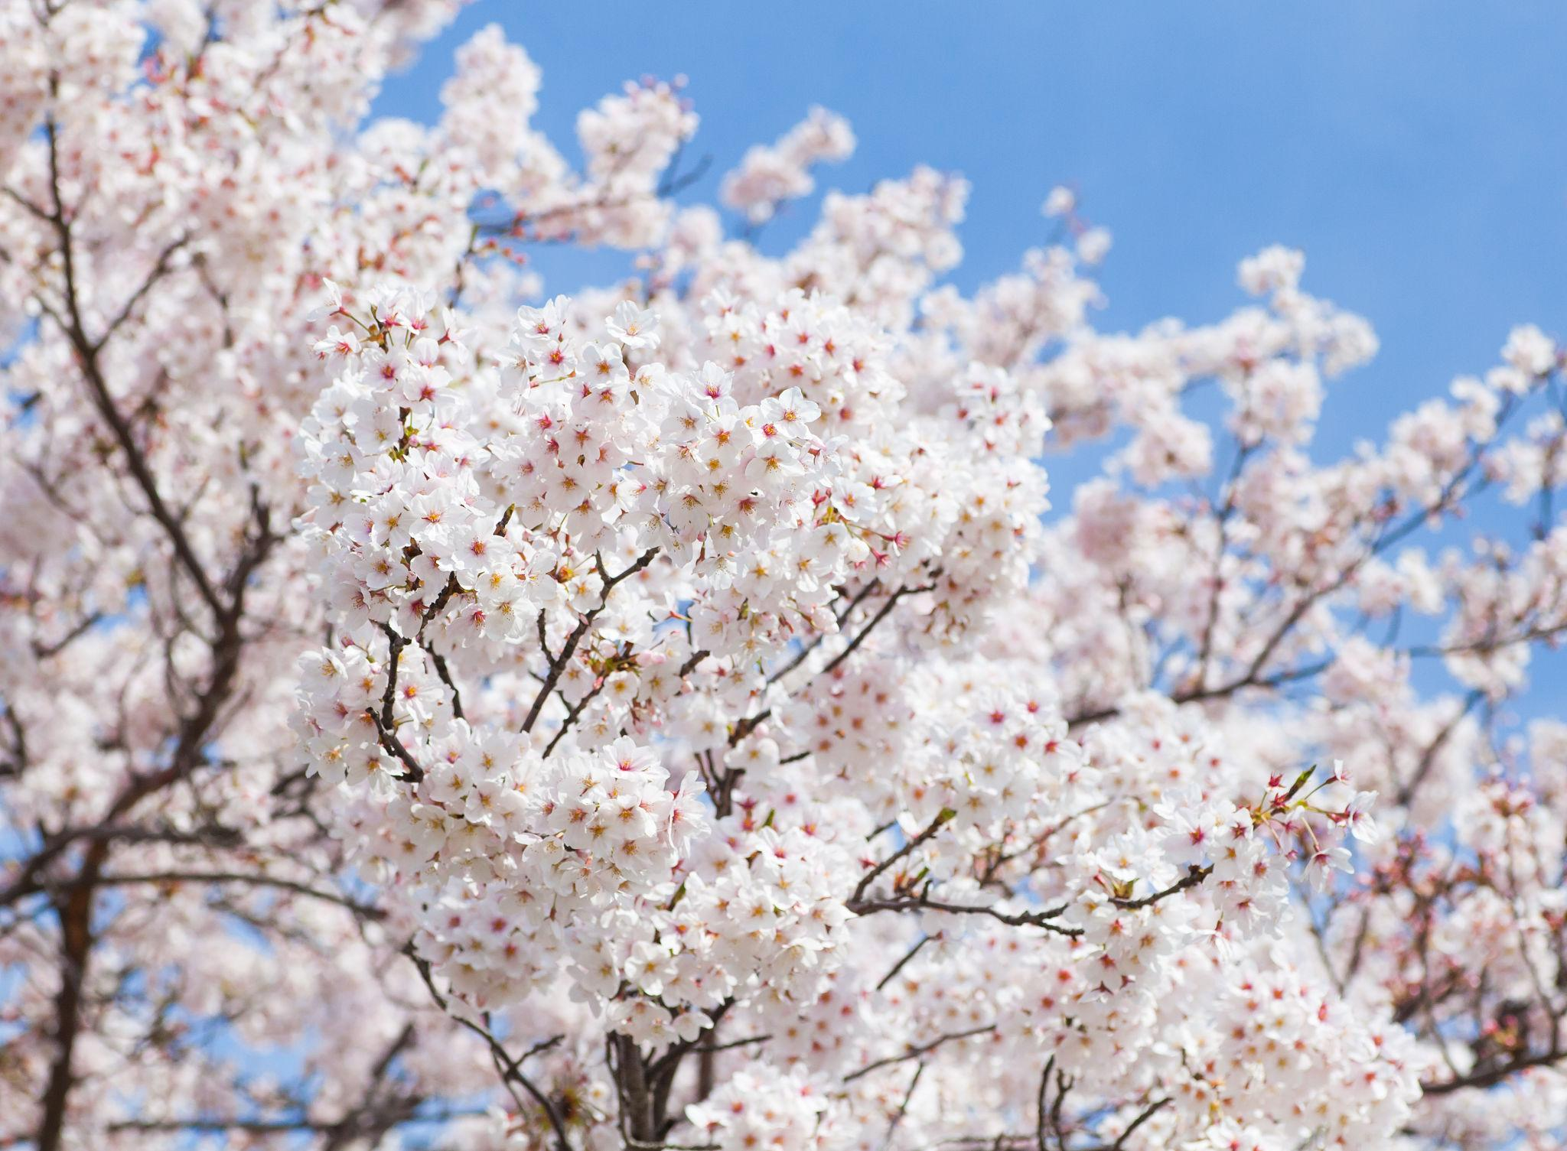
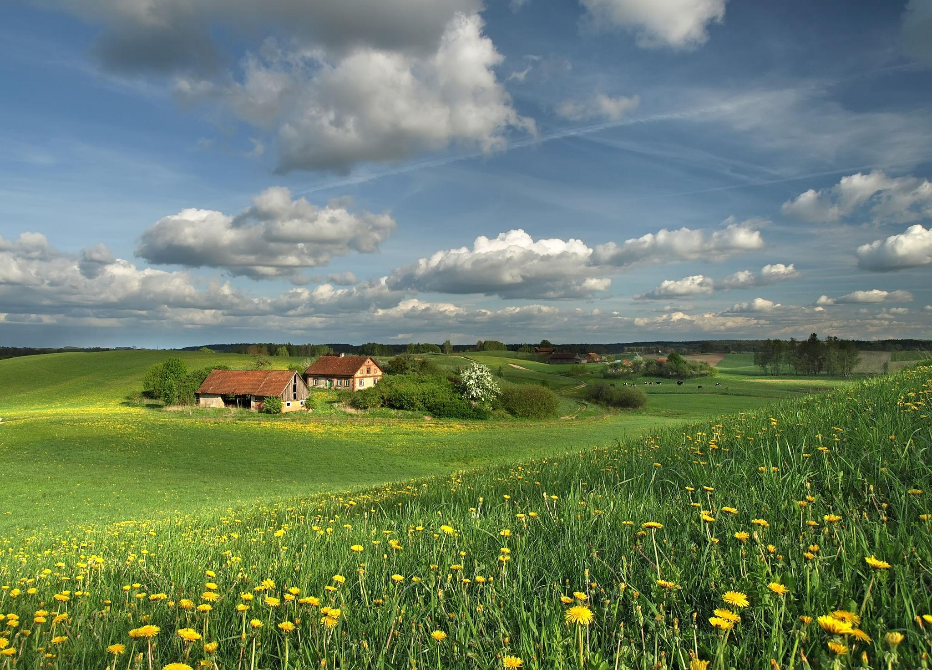
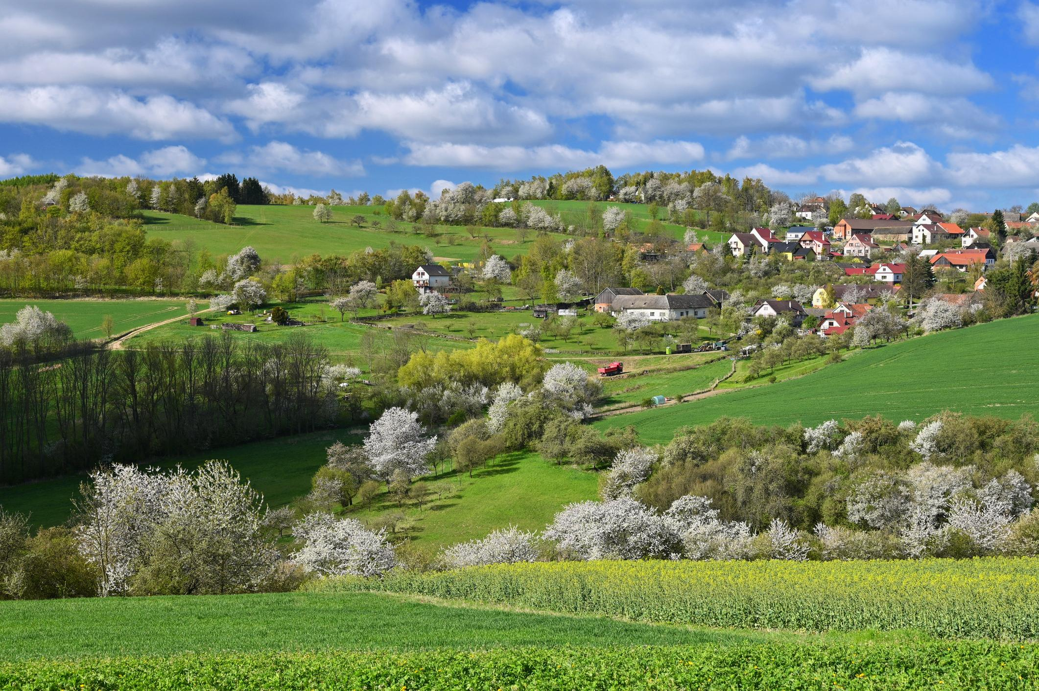
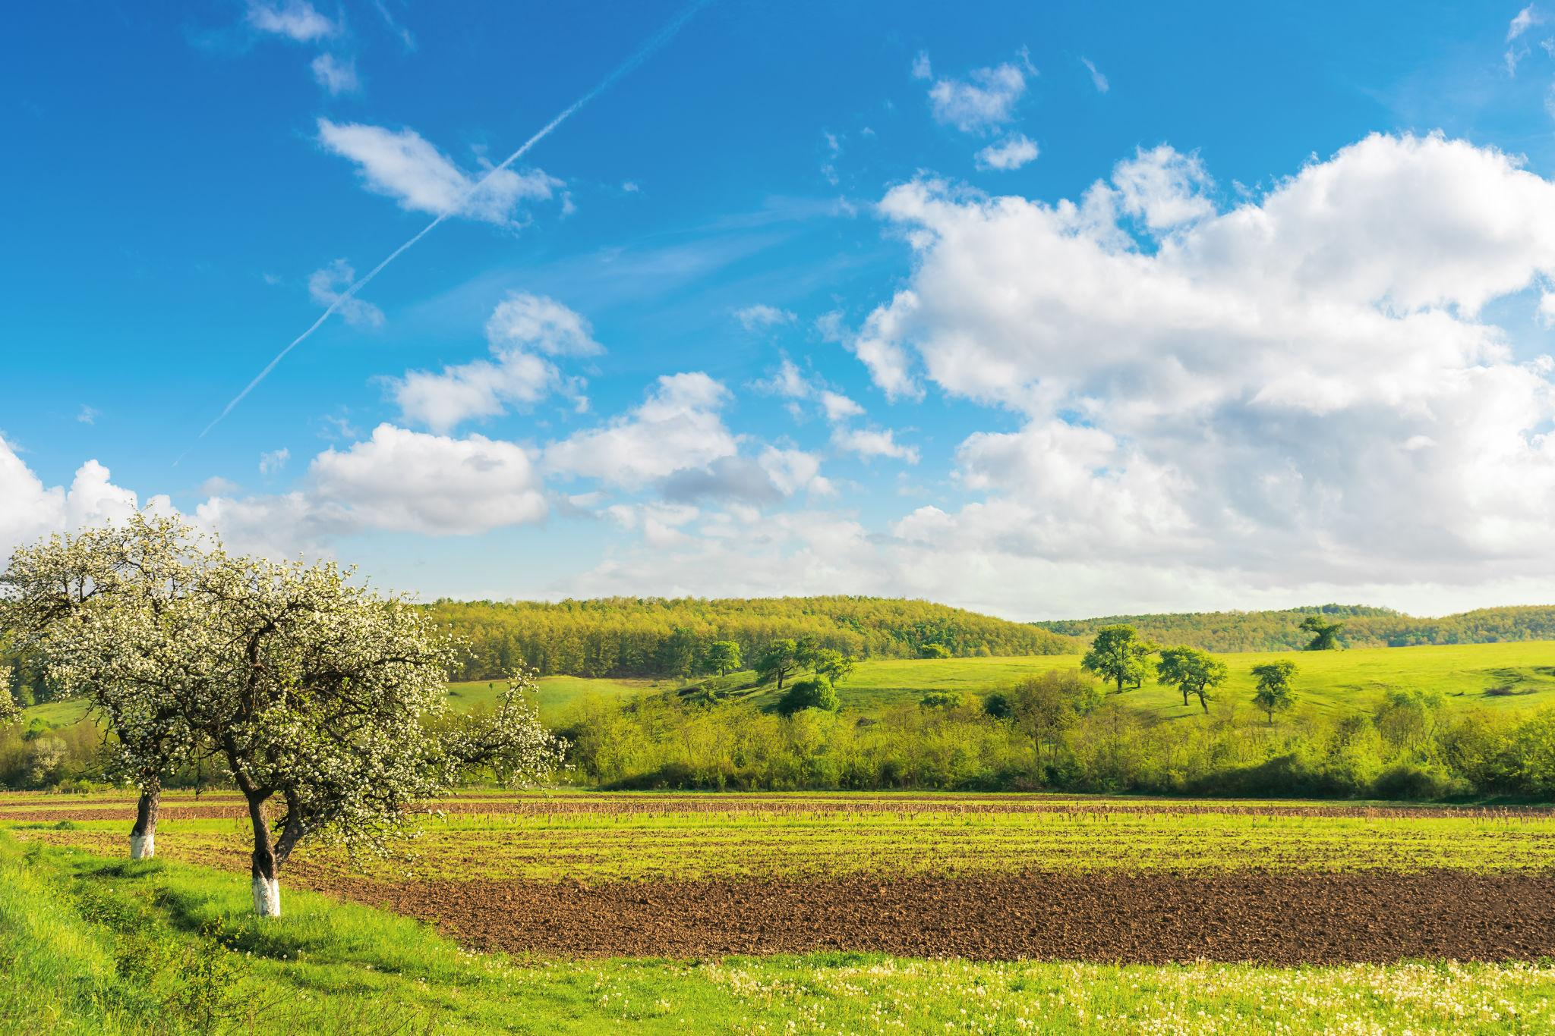
Spring is the season of renewal and growth that follows winter and precedes summer. During spring, temperatures gradually rise, daylight hours become longer, plants begin to grow, and many animals become more active after the colder months.
Spring begins because the Earth's tilted axis causes a hemisphere to receive increasingly direct sunlight as it moves toward summer.
To understand why spring occurs, see how Earth's position around the Sun changes the angle of sunlight throughout the year.

Definition
# Source: AI Source: Provided by: [Data Path: Persons Table -> ID Column: 1, Name_En Column: Motasem Essam] -> From: [ChatGPT] on [7/17/2026]
Spring is the season between winter and summer, characterized by increasing temperatures, longer daylight hours, renewed plant growth, and the awakening of many forms of animal life.

Position in the Year
# Source: AI Source: Provided by: [Data Path: Persons Table -> ID Column: 1, Name_En Column: Motasem Essam] -> From: [ChatGPT] on [7/17/2026]
Spring is:
- After Winter
- Before Summer

Typical Months
# Source: AI Source: Provided by: [Data Path: Persons Table -> ID Column: 1, Name_En Column: Motasem Essam] -> From: [ChatGPT] on [7/17/2026]
Northern Hemisphere
- March
- April
- May
Southern Hemisphere
- September
- October
- November

Beginning of Spring
# Source: AI Source: Provided by: [Data Path: Persons Table -> ID Column: 1, Name_En Column: Motasem Essam] -> From: [ChatGPT] on [7/17/2026]
Astronomical Spring
Begins at the:
- Spring (Vernal) Equinox
Around:
- March 20–21 (Northern Hemisphere)
- September 22–23 (Southern Hemisphere)
At the equinox:
- Day and night are nearly equal in length.

Weather Characteristics
# Source: AI Source: Provided by: [Data Path: Persons Table -> ID Column: 1, Name_En Column: Motasem Essam] -> From: [ChatGPT] on [7/17/2026]
Spring weather is generally:
- Mild
- Gradually warming
- More rainfall in many regions
- Variable from day to day
Typical conditions include:
- Comfortable temperatures
- Fresh air
- Occasional showers
- Increasing sunshine

Temperature
# Source: AI Source: Provided by: [Data Path: Persons Table -> ID Column: 1, Name_En Column: Motasem Essam] -> From: [ChatGPT] on [7/17/2026]
Compared with winter:
- Average temperatures increase.
- Frost becomes less common in many regions.
- Soil gradually warms, supporting plant growth.

Daylight
# Source: AI Source: Provided by: [Data Path: Persons Table -> ID Column: 1, Name_En Column: Motasem Essam] -> From: [ChatGPT] on [7/17/2026]
During spring:
- Days become longer.
- Nights become shorter.
- The Sun appears higher in the sky each day.

Changes in Nature
# Source: AI Source: Provided by: [Data Path: Persons Table -> ID Column: 1, Name_En Column: Motasem Essam] -> From: [ChatGPT] on [7/17/2026]
Spring is known for rapid changes in the natural world.
Plants
- Trees grow new leaves.
- Flowers bloom.
- Grass becomes greener.
- Seeds germinate.
- Crops begin growing.
Animals
- Birds return from migration.
- Many animals give birth.
- Insects become active.
- Pollinators such as bees and butterflies appear.

Agriculture
# Source: AI Source: Provided by: [Data Path: Persons Table -> ID Column: 1, Name_En Column: Motasem Essam] -> From: [ChatGPT] on [7/17/2026]
Spring is one of the busiest seasons for farming.
Activities include:
- Preparing fields
- Planting crops
- Fertilizing soil
- Irrigation
- Caring for young plants

Human Activities
# Source: AI Source: Provided by: [Data Path: Persons Table -> ID Column: 1, Name_En Column: Motasem Essam] -> From: [ChatGPT] on [7/17/2026]
People often:
- Spend more time outdoors.
- Begin gardening.
- Enjoy hiking and picnics.
- Participate in spring festivals.
- Clean homes (spring cleaning).

Major Spring Celebrations
# Source: AI Source: Provided by: [Data Path: Persons Table -> ID Column: 1, Name_En Column: Motasem Essam] -> From: [ChatGPT] on [7/17/2026]
Many cultures celebrate spring, including:
- Nowruz (Persian New Year)
- Easter (Christian tradition)
- Hanami (Japan's cherry blossom viewing)
- Various spring festivals around the world

Importance of Spring
# Source: AI Source: Provided by: [Data Path: Persons Table -> ID Column: 1, Name_En Column: Motasem Essam] -> From: [ChatGPT] on [7/17/2026]
Spring is important because it:
- Supports new plant growth.
- Begins many agricultural cycles.
- Increases biodiversity.
- Provides food for animals.
- Marks the transition from cold to warm weather.

Advantages
# Source: AI Source: Provided by: [Data Path: Persons Table -> ID Column: 1, Name_En Column: Motasem Essam] -> From: [ChatGPT] on [7/17/2026]
Spring provides:
- Moderate temperatures
- Longer daylight
- Beautiful landscapes
- Active wildlife
- Favorable conditions for farming

Common Mistakes
# Source: AI Source: Provided by: [Data Path: Persons Table -> ID Column: 1, Name_En Column: Motasem Essam] -> From: [ChatGPT] on [7/17/2026]
- Believing spring starts on the same calendar date everywhere (the exact date depends on the hemisphere and astronomical or meteorological definition).
- Confusing the Spring Equinox with the entire spring season.
- Assuming spring weather is always warm (it can still include cold days or late frosts).

Comparison with Other Seasons
# Source: AI Source: Provided by: [Data Path: Persons Table -> ID Column: 1, Name_En Column: Motasem Essam] -> From: [ChatGPT] on [7/17/2026]
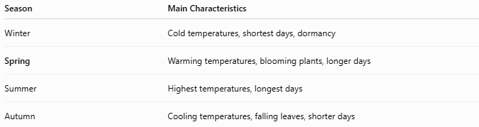
Season | Main Characteristics
Winter | Cold temperatures, shortest days, dormancy
Spring | Warming temperatures, blooming plants, longer days
Summer | Highest temperatures, longest days
Autumn | Cooling temperatures, falling leaves, shorter days

Key Points
# Source: AI Source: Provided by: [Data Path: Persons Table -> ID Column: 1, Name_En Column: Motasem Essam] -> From: [ChatGPT] on [7/17/2026]
- Spring is the season between winter and summer.
- It begins at the Spring (Vernal) Equinox.
- Temperatures gradually increase.
- Daylight becomes longer.
- Plants grow and bloom.
- Animals become more active.
- It is one of the most important seasons for agriculture.

Conclusion
# Source: AI Source: Provided by: [Data Path: Persons Table -> ID Column: 1, Name_En Column: Motasem Essam] -> From: [ChatGPT] on [7/17/2026]
Spring is the season of renewal, marking the transition from the cold of winter to the warmth of summer. As the Earth receives increasingly direct sunlight, temperatures rise, days grow longer, and ecosystems become active once again. The blooming of plants, the return of wildlife, and the start of agricultural activities make spring one of the most vibrant and productive seasons of the year.

